Physics 3A/3B

Motion and Forces in a Gravitational Field

Test 3

Torque and Structures



Time allowed: 1 Hour 34 marks

- Answer all questions on the paper provided
- To achieve full marks, clear, logical
working and diagrams MUST be shown.
- Answers should be evaluated with an
appropriate number of significant figures.

Section A: 4 Short answer Questions ( 12 marks )

- Explain with the aid of diagrams why a person carrying a large box must adjust their balance by leaning?


(3 marks)

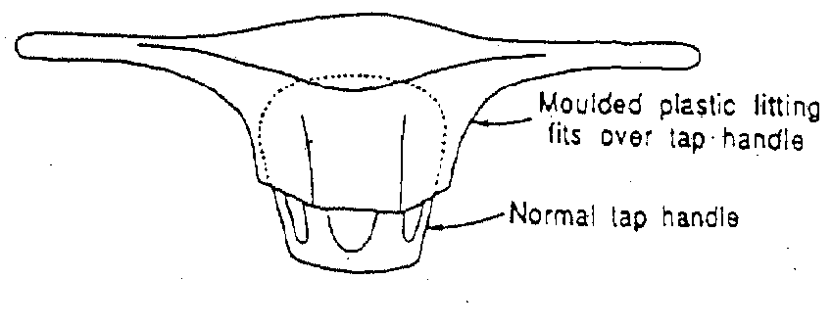
- People with severe arthritis in their hands often have difficulty turning taps on and off. A tap- making company has recognised this and developed a device that fits over the tap and has two arms as shown in the diagram.

Explain the principle upon which this device operates.

(3 marks)
- Calculate the force exerted by a biceps muscle when lifting a 3.00 kg mass. Assume the biceps muscle is attached 40.0 mm from the elbow joint and acts at right angles to the bone. The lower arm has a mass of 1.70 kg and is considered uniform.

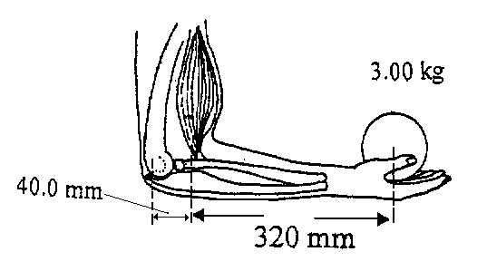

(3 marks)

- Explain with the aid of diagrams, why a double-decker bus becomes less stable as people are loaded into the upper deck of the bus?

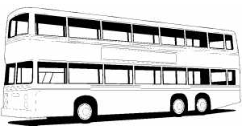

(3marks)
Section B: 3 Extended answer questions: 22 marks

- A shopkeeper wants to hang two signs from a 10.3 kg horizontal pole fixed to the wall.
The first sign has a mass of 5.20 kg and is to be hung 0.800 m from the wall.
The second sign has a mass of 6.60 kg and is to be hung 0.200 m from the free end of the pole. The pole is 2.00 m in length.

If the pole is to be supported by a vertical cable from the roof, the cable can only support 1.40 x 10² N, what is the minimum distance from the wall that the cable can be attached?

(4 marks)

- An 85 kg painter is using a plank, which rests on two trestles, to paint the upper section of a wall as shown. Assuming that the plank is uniform and has a mass 15 kg:
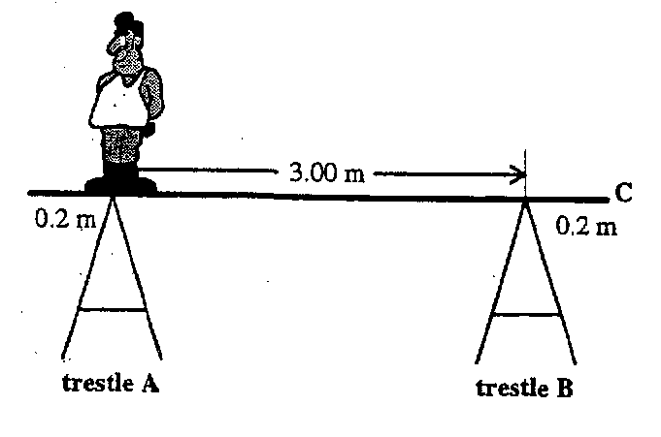
- Calculate the forces exerted by each trestle on the plank if the painters stands at trestle A

(5 marks)
- If the painter then stands at the end of the plank (point C), will the system remain in equilibrium? Justify your answer.

(3 marks)

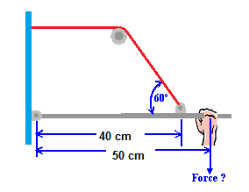
- A 60.0 cm lever is connected to a wire which activates a release mechanism inside the wall. The operator pulls down on the lever to activate the mechanism. The machine requires a 130.0 N tension in the cable in order to activate it.

The uniform lever arm has a mass of 15 kg.

- Calculate the minimum force required by the operator to activate the mechanism?
(4 marks)
- Calculate the reaction at the wall whilst the lever is in operation?
(Ignore forces where the cable meets the wall) (6 marks)

